 |  | EDUCATIONAL FISCOMISIONAL UNIT AUGUST 10  Código AMIE 08H01199  San Lorenzo-Ecuador |  |  |  |  |  |  | 
MICROCURRICULAR PLANNING 2026 – 2027
FIRST QUARTER
- INFORMATIVE DATA
TEACHER´S NAME: | YANET SOLIS |  |  | ÁREA: |  |  | FOREIGN LANGUAGE | SUBJECT: |  | ENGLISH
TEACHING UNIT: | CURRICULAR APPROACH |  |  | Título de la unidad didáctica: |  |  | GETTING TO KNOW YOU/ OUR FAMILIES, OUR WORLD”
GRADE/COURSE: | 8th A, B, C, D |  |  | No. of Week |  |  | 7 | START AND END DATE: |  | FROM JUNE 15 TO JULY 31, 2026
- LEARNING OBJETIVES
O.EFL 4.1 Identify the main ideas, some details and inferences of written texts, in order to produce level-appropriate critical analysis of familiar subjects and contexts. O.EFL 4.2 Appreciate and value English as an international language and a medium to interact globally. O.EFL 4.3 Independently read A2.1 level text in English as a source of entertainment and interpersonal and intrapersonal interaction. O.EFL 4.4 Develop creative and critical thinking skills when encountering challenges in order to promote autonomous learning and decision making. O.EFL 4.5 Introduce the need for independent research as a daily activity by using electronic resources (ICT) in class while practicing appropriate competences in the four skills. O.EFL 4.6 Write short descriptive and informative texts related to personal information or familiar topics and use them as a means of communication and written expression of thought. O.EFL 4.7 Use spoken and written literary text in English such as poems, short stories, comic strips, short magazine articles and oral interviews on familiar subjects in order to inspire oral and written production at an A2.1 level. O.EFL 4.8 Integrate written and spoken text in order to identify cultural differences and similarities within a range of local, national and global contexts familiar to the learner. O.EFL 4.9 Create a sense of awareness in terms of accuracy when learners interact in English using high-frequency and level-appropriate expressions in order to reach an effective command of spoken language.
- INSERCIÓN CURRICULAR |  |  |  |  |  | - VALUES
Social-Emotional Education  Sustainable Development  Road Safety  Financial Education  Civic Education |  |  |  |  |  | June: Generosity  July: Perseverance.
- STANDARDS:
CE.EFL.4.6. Listening for Meaning: Understand and follow the main idea in spoken texts set in familiar everyday contexts, provided speech is clear and articulate, and deduce the meanings of unfamiliar words and phrases using context clues and/or prior knowledge.
CE.EFL.4.7. Listening for Information: Follow and identify some main ideas and details in short and straight-forward spoken or audio texts set in familiar contexts, when delivered slowly and with visuals to provide contextual support. Use spoken contributions in class as models for one’s own speech.
CE.EFL.4.3. Interact with others using self-monitoring and self-correcting strategies as well as appropriate nonverbal and oral communication features.
CE.EFL.4.9. Production – Fluency: Use simple language to describe, compare and make statements about familiar everyday topics such as objects, possessions and routines in structured situations and short conversations. Interaction is with reasonable ease, provided speech is given clearly, slowly and directly.
CE.EFL.4.10. Interaction – Interpersonal: Participate effectively in familiar and predictable conversational exchanges by asking and answering follow-up questions, provided there are opportunities to use repair strategies (e.g. asking for clarification) and sustain conversational exchanges in pairs to complete a task, satisfy a need or handle a simple transaction.
CE.EFL.4.11. Demonstrate comprehension of main ideas and some details in short simple texts on familiar subjects, making use of contextual clues to identify relevant information in a text.
CE.EFL.4.15. Express information and ideas and describe feelings and opinions in simple transactional or expository texts on familiar subjects in order to influence an audience, while recognizing that different texts have different features and showing the ability to use these features appropriately in one’s own writing. CE.EFL.4.16. Make use of simple learning resources, including those created by one’s self, in order to compare and contrast information, and choose appropriate resources according to the value, purpose and audience of each.

- PLANNING:
ESSENTIAL  CONTENTS | SKILL WITH PERFORMANCE CRITERIA |  | EVALUATION INDICATORS | ACTIVE METHODOLOGICAL STRATEGIES FOR TEACHING AND LEARNING |  |  |  |  |  |  | EVALUATION  ACTIVITIES
WEEK 1  FROM JUNE 15 TO JUNE 19  - Greetings and farewells  - Introducing oneself  - Asking and answering names  - Classroom interaction | EFL 4.2.16. Initiate, maintain and end a conversation to satisfy basic needs and/ or handle a simple transaction.  |  | I.EFL.4.10.1. Learners can effectively participate in familiar and predictable everyday conversational exchanges in order to  complete a task, satisfy a need or handle  a simple transaction, using a range of repair strategies. (Example: asking for clarification, etc.) (I.3, J.3, J.4) | GREETING  CLASS OBJECTIVE  - EXPERIENCE:  Observation of images on page 7.  - Guided conversation about greetings they use daily.  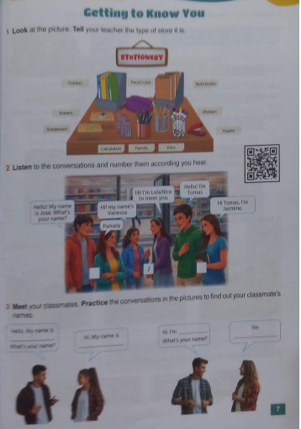  REFLECTION:  - They compare ways of greeting in English and Spanish.  - They identify formal and informal expressions.  CONCEPTUALIZATION:  Presentation of:  Hello  Hi  Good morning  What's your name?  My name is...  APPLICATION:  Role-playing activities using the dialogues from the book.  "Find a Friend" activity.   Complete the exercises on pages 7. |  |  |  |  |  |  | Technique: Rubric  Instrument: Oral dialogue rubric  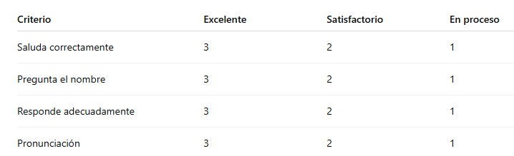  Resources  - English textbook  - Flashcards  - QR audio  - Whiteboard  - Markers
WEEK 2  FROM JUNE 22 TO JUNE 26  - Personal information  - First name and last name  - Address  - Telephone number  - E-mail address | EFL 4.2.11. Give short, basic descriptions of everyday activities and events within familiar contexts and use simple descriptive language to compare and make brief statements about objects and possessions. (Example: family, school, living conditions, personal belongings, etc.) |  | I.EFL.4.9.1. Learners can use simple language to describe, compare and state facts about familiar everyday topics such as possessions, classroom objects and routines in short, structured situations, interacting with relative ease. (I.3, I.4, S.4) |  | GREETING  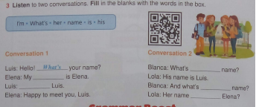  CLASS OBJECTIVE  EXPERIENCE  Listen to the audio on page 8 of the book once, twice, or even three times regarding personal information.  REFLECTION:  They discuss what personal information they know  CONCEPTUALIZATION:  Explain to the students about contractions, possessive adjectives, and questions words.  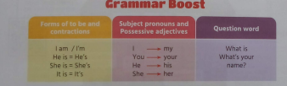  https://es.slideshare.net/slideshow/verb-to-be-question-wordspossessive-adjectives/67720456  APPLICATION:  • Pair interviews.  - Complete personal information.  - Activities pages 8-10. |  |  |  |  |  | Technique: Observation  Instrument: Checklist  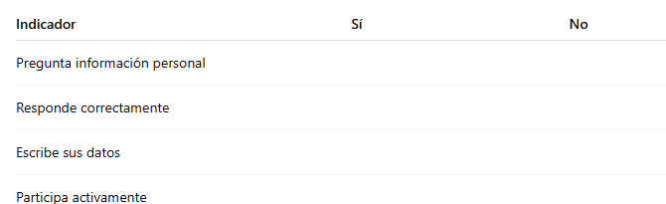  Resources  - Book  - Personal cards  - Cardboard  - QR code audio
WEEK 3  FROM JUNE 28 TO JULY 3  - Greetings  - Parts of a postcard  - Polite expressions | EFL 4.1.6. Seek and provide information  and assistance, orally or in writing and  in online or face-to-face interactions, for  personal, social and academic purposes.  EFL 4.4.5. Recognize that various types of  writing require different language, formatting and special vocabulary.(Example: a  recipe, a letter, etc.)  |  | I.EFL.4.4.1. Learners can demonstrate an ability to give and ask for information and assistance using level-appropriate language and interaction styles in online or face-to-face social and classroom interactions. (J.2, J.3, J.4, I.3)  I.EFL.4.15.1. Learners can convey information and ideas and describe feelings and opinions in simple transactional or expository texts on familiar subjects in order to influence an audience, while recognizing that different texts have different features and showing the ability to use these features appropriately in one’s own writing. (I.3, I.4, S.3, J.2) | GREETING  CLASS OBJECTIVE  EXPERIENCE:  Look at the page 11, read it, and then listen carefully once, twice, or even three times.    REFLECTION:  • They discuss how old they are in groups.  • Group discussion correcting, correcto or incorrect answers.  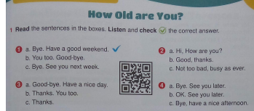  CONCEPTUALIZATION:  Teacher explains:  ✔ Parts of a postcard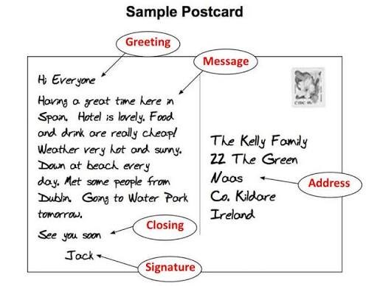  - Complete the information on the table:  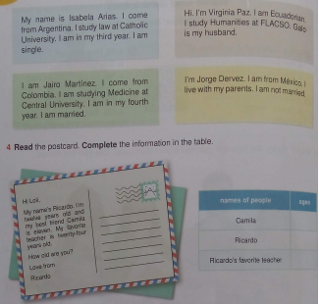  APPLICATION:  - Short interviews.  - Dialogues in pairs, page 11, exercise 3.  - Activities from the book, pag 12 |  |  |  |  |  |  | Technique: Rubric  Instrument: Oral participation  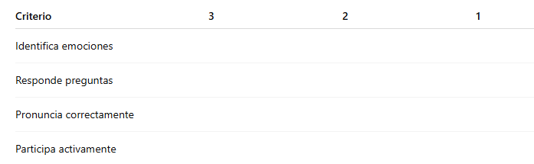  Resources  - Book  - Post card  - Audio  - Videos
WEEK 4  FROM JULY 6 TO JULY 10  - Countries  - Nationalities  - Cultural diversity  - Verb To Be + use apostrophe (s) | EFL 4.4.4. Write to describe feelings/ opinions in order to effectively influence an  audience. (Example: persuade, negotiate,  argue, etc.)    EFL 4.5.9. Engage in collaborative activities through a variety of student groupings to create and respond to literature  and other literary texts. (Example: small  groups, cooperative learning groups, literature circles, process writing groups,  etc.)  |  | I.EFL.4.15.1. Learners can convey information and ideas and describe feelings and opinions in simple transactional or expository texts on familiar subjects in order to influence an audience, while recognizing that different texts have different features and showing the ability to use these features appropriately in one’s own writing. (I.3, I.4, S.3, J.2)  I.EFL.4.22.1. Learners can collaborate and participate effectively in a variety of student groupings by employing a wide range of creative thinking skills through the completion of activities such as playing games, brainstorming and problem solving. (S.2, S.4, J.1, J.2, J.3, J.4) | GREETING  CLASS OBJECTIVE  EXPERIENCE  Watch the video about flags, take notes about nationalities https://www.youtube.com/watch?v=Z6cvRmyEUKc  REFLECTION  Discuss with the students: What country are these people from?    Complete the book pag, 13  CONCEPTUALIZATION  • Explanation of use apostrophe (s)  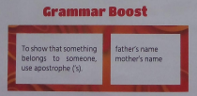  https://www.youtube.com/watch?v=5YE27Pn_c1g  APPLICATION  - Creating cultural cards.  - Short presentations about pag, 14  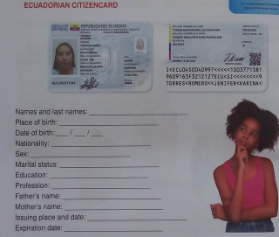  - Complete the worksheet:  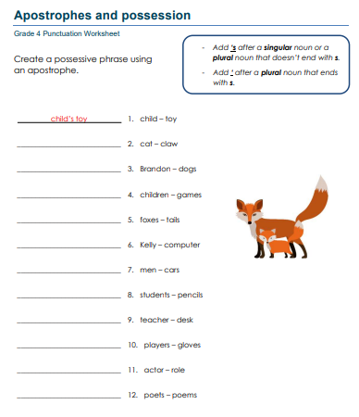 |  |  |  |  |  |  | Technique: Presentation  Instrument: Rubric  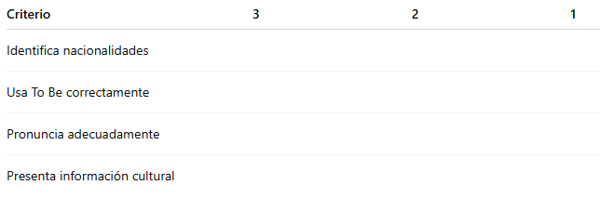  Resources  - Book  - World Map  - Flags  - Videos
WEEK 5  FROM JULY 13 TO JULY 17  - Family members  - Verb to be  - Possessive adjectives  - Family vocabulary | EFL 4.4.7. Use the process of prewriting,  drafting, revising, peer editing and proof  -reading (i.e., “the writing process”) to  produce well-constructed informational  texts.  EFL 4.4.9. Select and make effective use  of a range of digital tools to write, edit, revise, and publish written work in a way that  supports collaboration, learning, and productivity. (Example: image editing, Google  Drive, infographic makers, audio and video  editing, presentation apps, etc.) |  | I.EFL.4.17.1. Learners can convey and  organize information through the use of  facts and details and by employing various stages of the writing process, while  using a range of digital tools to promote  and support collaboration, learning and  productivity. (I.1, I.3, S.4,J.2, J.4). | GREETING  CLASS OBJECTIVE  EXPERIENCE  Look at the picture on page 15 of the book about family members  REFLECTION  Discuss with the students: How many people are in the image? Describe them.  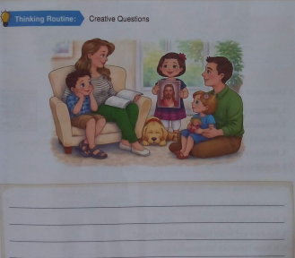  CONCEPTUALIZATION  - Explanation of verb to be, familiy members, ordinal numbers, possessive adjectives  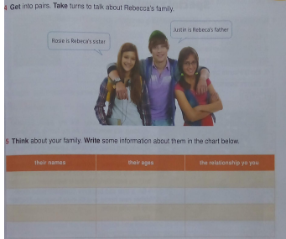  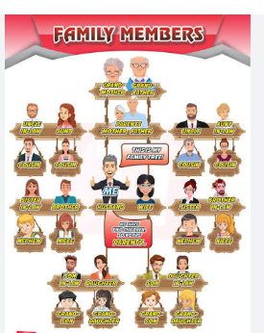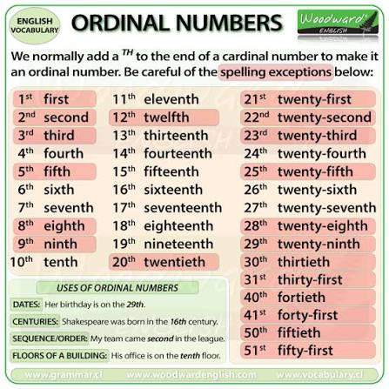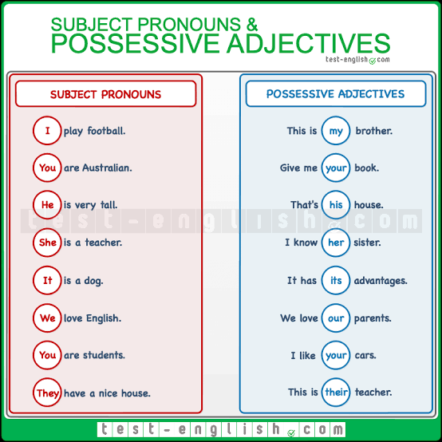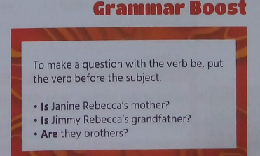  APPLICATION  - Oral description of your family.  - Book activities.pag, 17    - Listen and complete the pag,16 |  |  |  |  |  |  | Technique: Oral Production  Instrument: Rubric  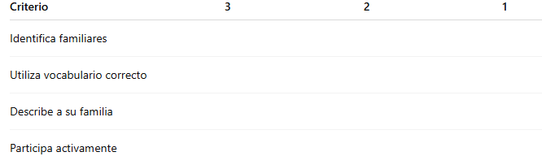  Resources  - Book  - Photographs  - Flashcards
WEEK 6  FROM JULY 20 TO JULY 24  - Family tree  Special Moments  - Feedback of possessive adjectives, Possessive´s  - Family relationships  - Personal descriptions | EFL 4.2.1. Understand phrases and expressions related to areas of most immediate  priority within the personal and educational domains, provided speech is clearly  and slowly articulated. (Example: daily life,  free time, school activities, etc.)  EFL 4.2.5. Understand most changes in  the topic of discussion if people speak  slowly. |  | Learners can grasp the general meaning of spoken texts set in familiar everyday contexts and infer changes in the topic of discussion. (Ref.I.EFL.4.6.1.) (I.3, S.1, J.4) | GREETING  CLASS OBJECTIVE  EXPERIENCE  - Look and read and Elena´s diary pag 18  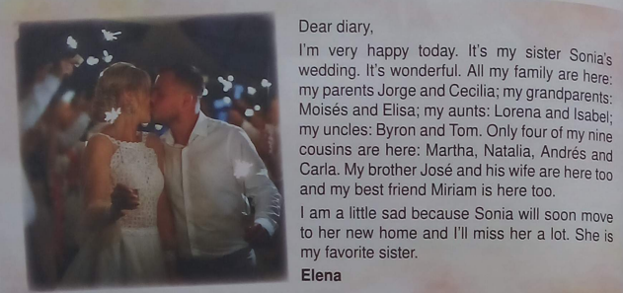  REFLECTION  - Discuss with the students whether the following sentences are true or false. Complete the pag, 18  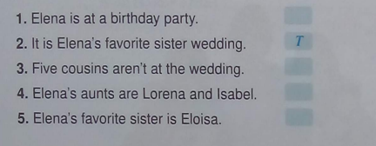  CONCEPTUALIZATION  - Feedback of possessive adjectives, Possessive´s  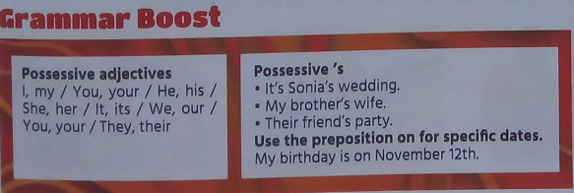  APPLICATION  - Listen to the audio recordings on page 19 of the book.  - Complete the text on page 20.  - Oral presentation about your family using possessive adjectives and possessives (page 21). |  |  |  |  |  |  | Technique: Direct observation  Instrument: Checklist  Evaluation criteria:  Recognizes specific information from the audio.  Correctly identifies family members.  Matches names with the relationships mentioned.  Actively participates during the listening activity.  Technique: Oral presentation  Instrument: Analytical rubric  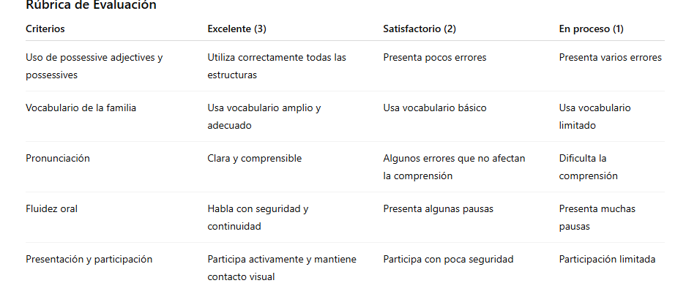  Resources  - English textbook (pages 19, 20, and 21)  - QR audio of the book  - Audio player or cell phone  - Flashcards of family members  - Family photographs (optional)  - Workbook  - Whiteboard and markers  - Printed assessment rubric  - Printed checklist
WEEK 7  FROM JULY 27 TO JULY 31  - Family tree  - Family relationships  - Present Simple (affirmative, negative, and interrogative forms)  - Daily routines and family activities  - Personal and family descriptions | EFL 4.2.11. Give short, basic descriptions  of everyday activities and events within familiar contexts and use simple descriptive  language to compare and make brief statements about objects and possessions.  (Example: family, school, living conditions,  personal belongings, etc.)   EFL 4.4.2. Make and use a simple print or  digital learning resource to compare and  contrast information in order to demonstrate understanding and command of a  topic.   |  | I.EFL.4.9.1. Learners can use simple language to describe, compare and state  facts about familiar everyday topics such  as possessions, classroom objects and  routines in short, structured situations, interacting with relative ease. (I.3, I.4, S.4)  Learners can create and use simple print  or digital learning resources to compare  and contrast information on a topic, demonstrating understanding, and can critically evaluate and recommend appropriate sources based on their value, purpose,  and audience. (Ref.I.EFL.4.16.1.) (I.1, I.3,  I.4, J.2, J.4) | GREETING  CLASS OBJECTIVE  EXPERIENCE  - Looking at family photographs and family trees.  - Guided discussion about activities they do with their families.pag,22  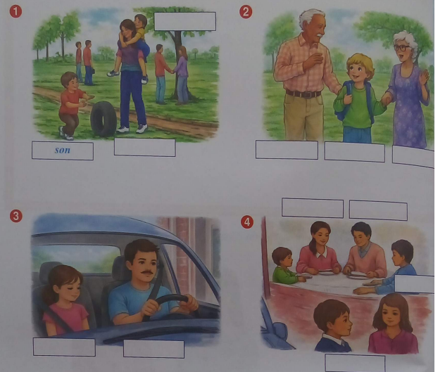  Motivating questions:  - What do you do with your family on weekends?  - Who lives in your house?  REFLECTION  They compare their classmates' family routines. What do you know about single parents? Share your ideas with your teacher.  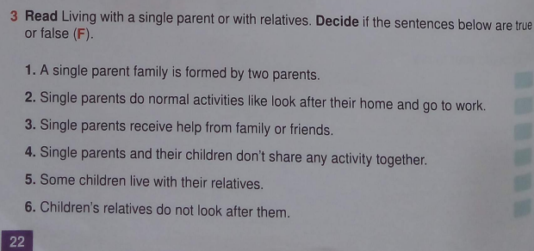  CONCEPTUALIZATION  Introduction about the structures: pag,23  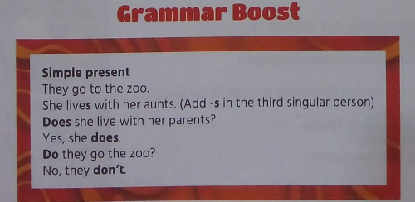  Simple present tense  - My mother works at home.  - My father drives a car.  - My grandparents live in the countryside.  - We usually have dinner together.  - Does your brother play soccer?  - Yes / No  APPLICATION  - Complete the reading comprehension exercises with the simple present tense on pages 23-24.  - Write 5 to 8 sentences using the Present Simple tense to describe your family members.  - Complete Unit Evaluation 2 on pages 25-26. |  |  |  |  |  |  | Technique: Performance Analysis  Instrument: Reading Comprehension Questionnaire (exercises from the textbook)  Evaluation Criteria:  Identifies specific information from the text.  Understands main and supporting ideas.  Correctly uses the Present Simple tense in responses.  Completes activities independently.  Technique: Written Production  Instrument: Analytical Rubric  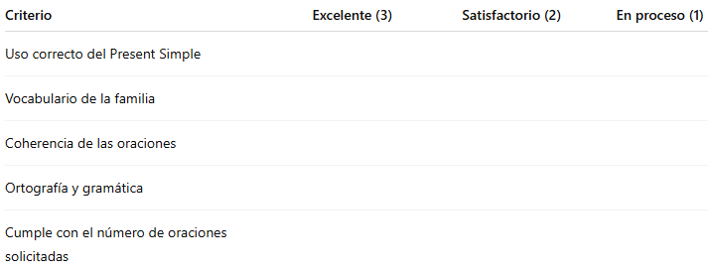  Technique: Objective Test  Instrument: Evaluation Questionnaire from the textbook  Evaluation Criteria:  Recognizes vocabulary from the unit.  Correctly uses the Present Simple tense.  Identifies family relationships.  Understands short texts and responds appropriately.  Applies the content covered during the unit.
RESOURCES |  |  | - Projector  - Flashcards  - Videos  - Posters  - Dictionary  • English textbook  • QR audio of the book  • Family photographs (optional)  • Workbook  • Whiteboard and markers  • Printed assessment rubric  - Printed checklist

ELABORATED BY: | ELABORATED BY ENGLISH DIRECTOR: | APROBED BY SUBDIRECTOR:
Lic. Yanet Solis | Ing. Juan Carlos Cobos | MsC Elizabeth Valencia Corozo
Firm: | Firm: | Firm:
Date: 15-6-2026 | Date: | Date:

